**PIZZA SALES SQL QUERIES**

**A.KPI’S**

**1.Total_Revenue:**

select sum(total_price) as Total_Revenue

from pizza_sales

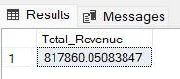

**2.Average Order Value:**

select sum(total_price)/COUNT(DISTINCT order_id) as Avg_Order_Value

from pizza_sales



**3. Total Pizzas Sold:**

select sum(quantity) as Total_pizzas_sold

from pizza_sales

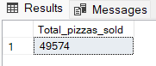

**4. Total orders:**

SELECT Count(distinct order_id) as Total_orders

from pizza_sales

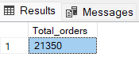

**5. Average Pizzas per order:**

SELECT cast(CAST(sum(quantity) AS decimal (10,2))/

cast(count(distinct order_id) as decimal(10,2)) as decimal(10,2))

as Avg_pizzas_per_order from pizza_sales

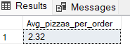

6. TOP 5 PIZZAS BY QUANTITY

select TOP 5 pizza_name, sum(total_price) as Total_Revenue

from pizza_sales

group by pizza_name

order by Total_Revenue desc

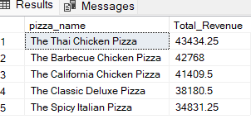

**7. BOTTOM 5 PIZZAS BY QUANTITY**

select TOP 5 pizza_name, sum(total_price) as Total_Revenue

from pizza_sales

group by pizza_name

order by Total_Revenue

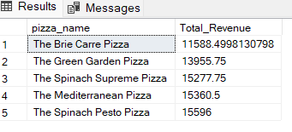

**8. PERCENTAGE SALES BY PIZZA SIZE**

SELECT pizza_size,ROUND(sum(total_price),2) as Total_Sales,

round(sum(total_price) * 100 /(select sum(total_price) from pizza_sales where DATEPART(quarter,order_date)=1 ),2) as PCT

from pizza_sales

where DATEPART(quarter,order_date)=1

group by pizza_size

order by PCT DESC

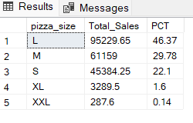

**9. HOURLY TREND FOR TOTAL ORDERS**

SELECT DATEPART(HOUR, order_time) as order_hours , count(distinct order_id) as total_orders

from pizza_sales

group by datepart(hour,order_time)

order by datepart(hour,order_time)

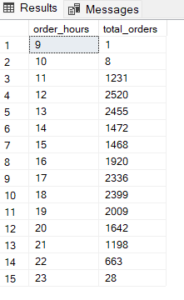

**10. DAILY TREND FOR TOTAL ORDERS**

SELECT DATENAME(DW,order_date) as order_day, COUNT(DISTINCT order_id ) as Total_orders

from pizza_sales

group by DATENAME(DW,order_date)

